Architecture Solution Design

TA Appian

[RITM0900319 | ACBSD-3138]

Version Control
Version Control |  |  |  |  | Approvals
Version | Date | Author/  Updated By: | Status | Comment | Pre-ARB | GTS ARB | Global ARB | GITB
01.00.00 | 2025-2-13 | Jarred Recker | Initial Document |  | ☒ | ☒ | ☐ | ☐
 |  |  | Choose an item. |  | ☐ | ☐ | ☐ | ☐
 |  |  | Choose an item. |  | ☐ | ☐ | ☐ | ☐
 |  |  | Choose an item. |  | ☐ | ☐ | ☐ | ☐
 |  |  | Choose an item. |  | ☐ | ☐ | ☐ | ☐
 |  |  | Choose an item. |  | ☐ | ☐ | ☐ | ☐
 |  |  | Choose an item. |  | ☐ | ☐ | ☐ | ☐

Table of Contents
Version Control 2
Table of Contents 3
1. Distribution and Contacts 6
2. Summary 7
2.1 Background 7
2.2 Solution Description 7
2.3 Business Unit(s) Impacted 7
3. Requirements 8
3.1 Use Cases 8
3.1.1 Use Case Requirements 8
3.2 Business Requirements 8
3.3 Functional Requirements 8
3.4 Non-Functional Requirements 9
Observability, Logging and Monitoring Requirements 9
Fault Tolerance & Resiliency Requirements 9
Availability Objectives 9
Performance Requirements 9
Capacity Requirements 9
3.5 Security Requirements 10
Security Requirement 10
3.6 Data Requirements 10
Data Requirement 10
3.7 Capability Map 10
4. Architecture 11
4.1 Alignment to Principles 11
4.2 Baseline Architecture 12
4.3 Target Architecture 13
4.3.1 Overview 13
4.3.2 Technology Components & Architecture Impacts 13
4.3.3 Gap Analysis 14
5. Components 15
5.1 Components or Patterns Used 15
5.1.1 Component Architecture Diagram 16
5.1.2 Components or Pattern Table 16
5.2 Integration Architecture 17
5.2.1 Integration Architecture Diagram 17
5.2.2 Integration Architecture Table 17
5.3 Data Flow 17
5.3.1 Data Flow Diagram 18
5.3.2 Data Flow Table 18
5.4 Data Protection 19
5.4.1 Backup and Recovery 19
5.4.2 High Availability 19
5.4.3 Disaster Recovery 19
5.5 Observability 19
5.6 Authentication and Authorization 19
5.7 Security Boundaries 19
5.7.1 Security Boundaries Diagram 19
5.7.2 Security Boundaries Table 20
5.7.3 Security Review Outcomes 20
5.7.4 Threat Model Assessment 20
6. Data Solution 21
6.1 Data Classification 21
6.2 Privacy Impact Assessment (PIA) 21
6.3 Data Encryption 21
6.4 Data Retention 21
6.5 Data Residency 21
6.6 GenAI (Future v.3) 21
7. Service Model 23
7.1 Shared Responsibilities 23
7.2 RACI Chart 23
8. Implementation Approach 25
8.1 Proposed level of coordination 25
8.2 Dependencies 25
9. Licensing 25
10. Artifacts 26
11. Waivers and/or Exceptions 27
11.1 Risk Exceptions 27
11.2 Risk Remediations 27
11.3 Security Exceptions 27
12. Estimated Costs 29
12.1 Financial Considerations 29
12.2 Non-Financial Considerations 29
12.3 Cost Benefit Analysis 29
12.4 Financial Assumptions 30
12.5 Resourcing Considerations 30
13. Exit Strategy 31

Distribution and Contacts
This document and future updates to be shared with the business representatives shown below.
Business Contacts and Information
Requester | Arjun Appikatla
Business DPO | Cheri Walker
Business ISO | Jordan Hoffman  Kyle Briggs
Business Architect | Arjun Appikatla
BCP Manager | Stephanie Weaver
Business Unit | TA
Cost Center | 0701-TT043000
Cost Center Owner | Priyank Tripathi
Product / Service Owner | Jason Oldfather
GTS Contacts and Information
GTS DPO | Adam Kaminski
GTS ISO | Nick Russell & Daniel Lartey
GTS Architecture | Jarred Recker
GTS Technology Risk Assessment | Mark Scarloss

Summary

Background
Transamerica has been using AWD as workflow tool for the past two decades+, which has become out of date and requires significant investment to get up to date or needs to be replaced. Transamerica has evaluated a number of products and has selected Appian to replace AWD as their workflow tool.

Solution Description
Transamerica is seeking to implement Appian to completely replace AWD as TA’s primary workflow tool. Over the years AWD has been integrated with several systems and processes which will take significant effort to analyze business processes and rebuild in Appian which is expected to take 2+ years. This initial design is to define the baseline architecture to begin development, which will be incrementally updated as TA identifies new requirements for each line of business.
Design goals include:
- Provide omnichannel experience around work items, and customer communications.
- Provide the platform capable to reengineer workflows to improve productivity.
- Target to reduce workflows by 60% or more under business child initiatives.
- Hosted cloud solution leading to reduction in operational and maintenance costs.
- Provide ability for customer self-service through the IVR and Portals

Business Unit(s) Impacted
The following Country/Business Unit(s) will be impacted by this Solution Design:
☒ | TA Individual | ☐ | Spain
☒ | TA Workplace | ☐ | HR Global
☒ | TA Finance | ☐ | ASIA/TLB
☒ | TA | ☐ | Corporate Centre
☐ | UK | ☐ | AAM
☐ | NL | ☐ | Other (Specify) _________________
☒ | GTS | ☐ | Global

Requirements

Use Cases

Key Objectives
  - Provide cost effective, modern cloud-based Workflow Platform
  - Gain efficiency and reporting ease across CSRs, Ops, Fraud, Compliance
  - Capture Efficiencies with Intelligent Document Processing and Omnichannel Client Communications
  - Consolidate existing workflows reducing complexity, and duplication by implementing activity-based workflow which is industry best practice.
  - Eliminate out of support applications and redundant solutions, which were born from AWD deficiencies.
  - A modern technology that encourages citizen development to accomplish business process reengineering, improving engagement and self service
  - Allows custom UIs by Role/Persona to speed up processing by function.
  - Intelligent Document Processing (IDP) and Classification for handling documents and routing work in an automated fashion
  - Possibility to offer expanded CX self-service options for customers and agents, easily with little to no development effort.
  - Offers Realtime Integration with IVR for status information, without impacting operations, nor requiring large data effort.
  - Leverage AI Copilot for reporting, analysing data.
  - Use AI Copilot for developers to build interfaces quicker
Scope
Complete replacement of AWD and associated workflows over next ~3 years.

Business Requirements

Business Requirements
Req. # | Requirement Details | Priority
BR. 1.0 | Support Business Process Model Notation (BPMN 2.0). BPMN is an industry standard for graphical representation for specifying business processes in a business process model. | Must Have
BR. 2.0 | Support low-code/no code service integration – “citizen” development model | Must Have
BR. 3.0 | Provide omnichannel experience around work items, and customer interaction | Must Have

Functional Requirements
Functional Requirements
Req. # | Req. Category | Requirement Details | Priority
FR.1.0 | Technology component | Ease of Integration (Document Management)/ Out of the box Adapters for Data, Communications, etc. | Must Have
FR.2.0 | Technology component | Multi-Cloud support (AWS and Azure) | Must Have
FR.3.0 | Operational | Supports our CAB Release process | Must Have
FR.4.0 | Operational | Modernize and reengineer workflows in the cloud, leading to lower maintenance overhead | Must Have
FR.5.0 | Operational | Enable intelligent document processing and classification | Must Have

Non-Functional Requirements
Non-Functional Requirements
Req. # | Req. Category | Requirement Details | Priority
NFR.1.0 | Observability, Logging and Monitoring Requirements | SIEM logging to Enterprise Standard (Splunk) | Must Have
NFR.2.0 | Fault Tolerance & Resiliency Requirements | Solution requires highly resilient design as Appian will be a critical application for TA operations. Multi-AZ and multi-region deployment | Must Have
NFR.3.0 | Availability Objectives | 99.99% Uptime SLA | Must Have
NFR.4.0 | Performance Requirements | N/A to be defined by BU | TBD
NFR.5.0 | Capacity Requirements | N/A – to be determined | TBD

Security Requirements

Security Requirements
Req. # | Req. Category | Requirement Details | Priority
SR.1.0 | Security Requirement | Data Encryption: Ensure that data in transit and at rest is encrypted using strong encryption protocols like TLS 1.2 or higher. This helps protect sensitive information from unauthorized access | Must Have
SR.2.0 | Security Requirement | Implement robust authentication mechanisms to verify user identities and ensure that only authorized users can access specific resources. | Must Have
SR.3.0 | Security Requirement | Define and enforce access controls to restrict who can access and modify application data and resources. This includes implementing least privilege principles and regularly reviewing access permissions | Must Have

Data Requirements
Data Requirements
Req. # | Req. Category | Requirement Details | Priority
DR.1.0 | Data Requirement | Ensure that sensitive data is protected from unauthorized observation or disclosure both in transit and when stored. | Must Have
DR.2.0

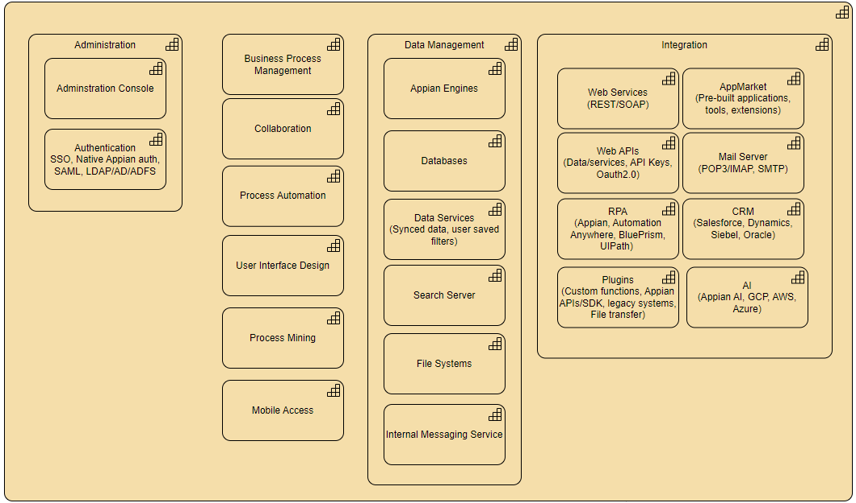
Capability Map

Architecture

Alignment to Principles
Architecture Principles (sharepoint.com)
Architecture Principles Alignment |  | Justification for lack of alignment (or a comment)
☒ | Capability Driven
☒ | Data Excellence
☒ | Modern
☒ | Secure and Compliant
☒ | Transparent
☒ | Future Proof
☒ | Reliable
☒ | Interoperable
☒ | Standardized
☒ | Value Oriented

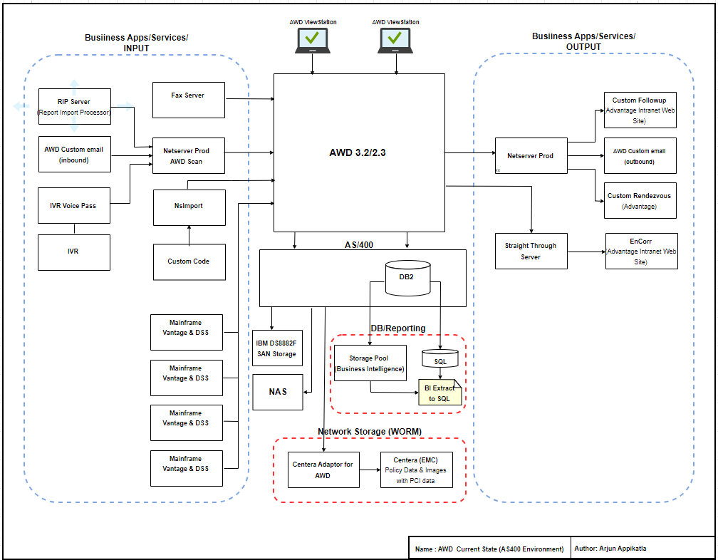
Baseline Architecture

Target Architecture

Overview
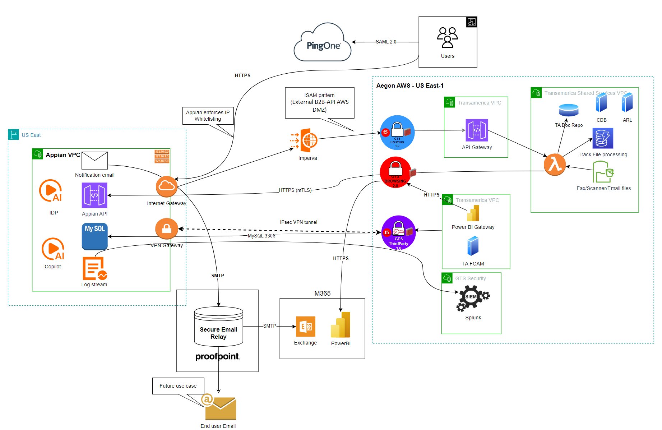

User access via SSO
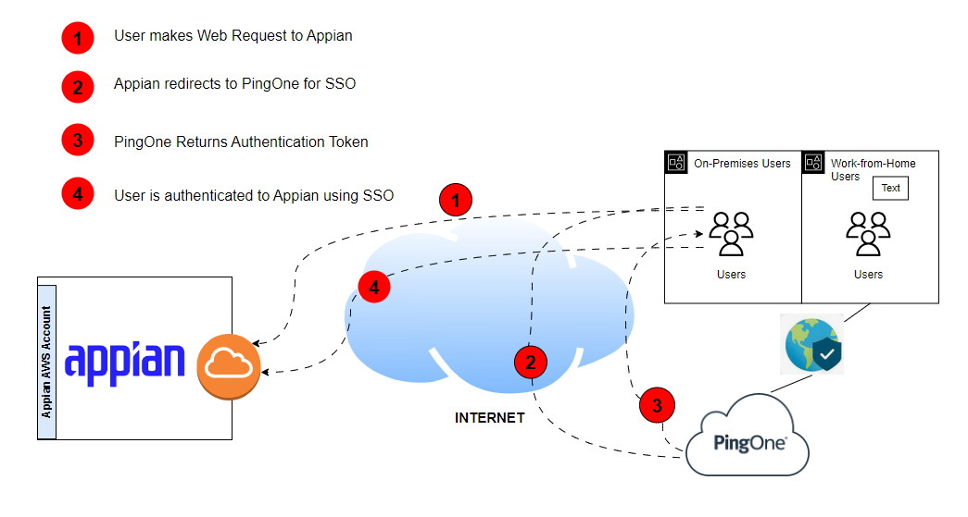

Technology Components & Architecture Impacts
List the technology components impacted by the change.

Technology Component Type | Technology Component Name | CMDB ID | Architecture Impact | Tech Lifecycle Strategy | Application Risk Rating
Business Application, Software, Hardware, Cloud Component | Application Name, Software Name, Hardware Name, Cloud Component Name | CMDB ID if in the CMDB  If not in the CMDB, indicate ‘New’  Prior to Project Solution - Final ARB, ‘New’ items must have a CMDB id to receive a passing score within the Architecture Alignment to Standards scorecard | Replace, Decom, Migrate, Re-use, Enhance, New | Buy, Hold, Sell  This is located in the Application IT Compliance Data in CMDB.  Search for the application an select the latest UPDATED date. The Application Lifecycle Strategy is on the right | Application Risk Rating is found by clicking on the link within the Application IT Compliance Data tab at the bottom of the application’s CMDB entry
Business Application | Workflow Appian | APM0005087 | New | Buy/Invest | TBD
Business Application | PingOne | CI047309632 | Re-use | Buy/Invest | High
Business Application | TA AWS DOCUMENT REPOSITORY | CI037910734 | Re-use | Buy/Invest | Medium
Business Application | PowerBI | CI018550651 | Re-use | Buy/Invest | Low
Business Application | TA FCAM | CI071178847 | New | Buy/Invest | High
Business Application | Splunk | APM0001365 | Re-use | Hold/Maintain | High
Business Application | Proofpoint Secure Email Relay | APM0003988 | Re-use | Hold/Maintain | Low
Business Application | Exchange Online | CI001936178 | Re-use | Hold/Maintain | High

Components

Components or Patterns Used
This will include the logical high-level architecture diagram based on the previous contextual diagram and a list of components used in the solution (use links when possible).
GTS Component Architecture Standards (sharepoint.com)
GTS Reference Architectures (sharepoint.com)
GTS Architectural Patterns (sharepoint.com)

Component Architecture Diagram

Components or Pattern Table
Components/Patterns Used |  | Link
1 | Appian Cloud | n/a
2 | GTS Hosting Pattern | Link
3 | TA API Gateway | Link
4 | TA Doc Repo | n/a
5 | GTS 3rd Party network | Link
6 | TA FCAM | n/a
7 | PowerBi gateway | Link
8 | GTS browsing pattern | Link
9 | AWS Lambda | Link
10 | ProofPoint Secure Email Relay | Link
11 | Exchange Online | n/a
12 | PowerBI | n/a

Integration Architecture

Integration Architecture Diagram
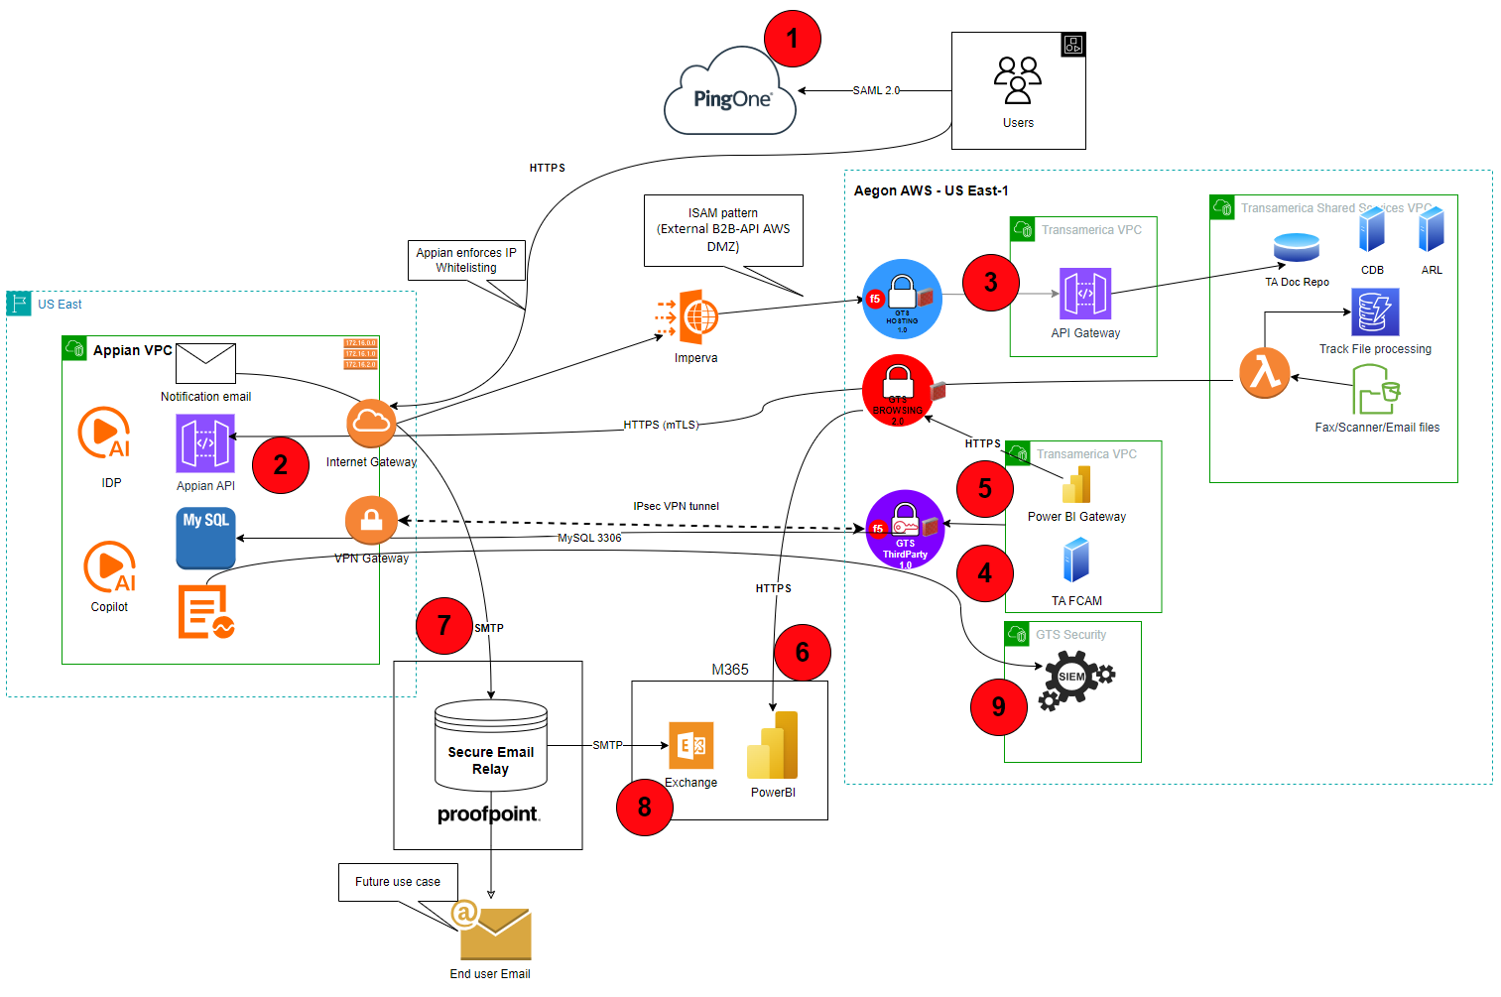

Integration Architecture Table
Connection | Source  Component | Target  Component | Purpose | Security Integration Pattern Name
1 | Users | PingOne | SSO for user access to Appian | PingOne
2 | Lambda Function | Appian API | Send files for analysis and processing | 3rd Party API
3 | Appian | TA API Gateway | Query TA data | AWS API gateway
4 | TA FCAM | Appian DB | Query DB for financial crimes reporting | External business partner VPN connection
5 | PowerBI Gateway | Appian DB | Query DB to for PowerBI reporting | External business partner VPN connection
6 | PowerBI Gateway | PowerBI platform | Broker connection to Appian data | PowerBI data gateway
7 | Appian messaging | Proofpoint Secure Email Relay | Send notification emails from Appian to TA staff | Proofpoint Secure email relay
8 | Proofpoint Secure Email Relay | Exchange Online | Send notification emails from Appian to TA staff | Proofpoint Secure email relay
9 | Appian event log stream | Splunk | Stream security events | Splunk log streaming

Data Flow

Data Flow Diagram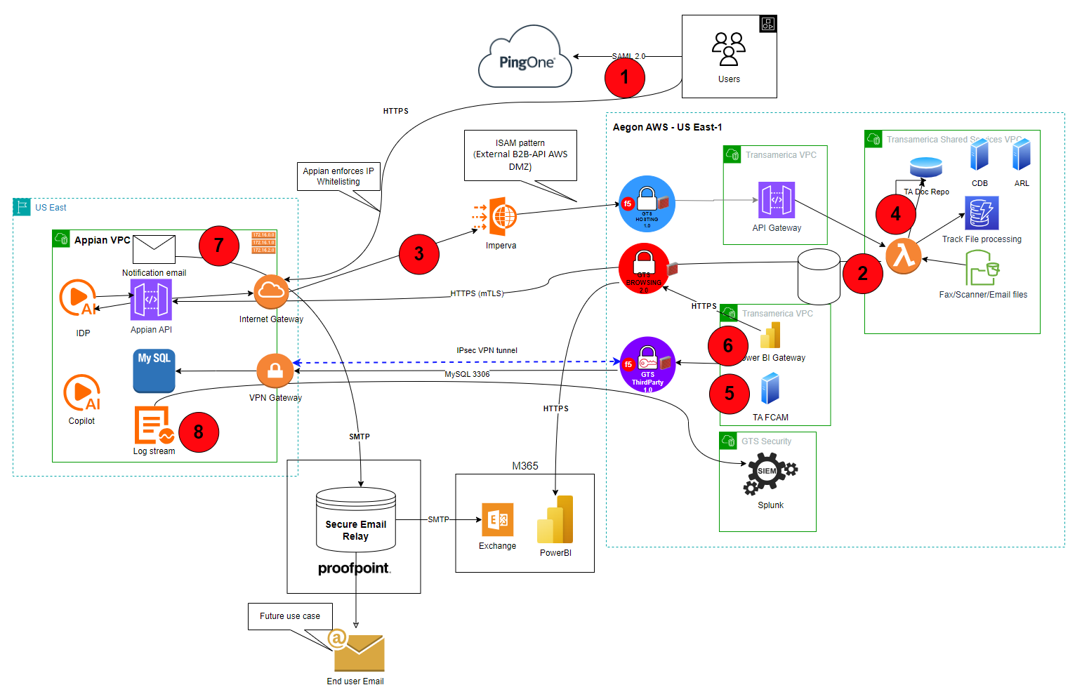

Data Protection

Backup and Recovery
All the relevant customer application data submitted to Appian Cloud and necessary for the proper operation of the system is included in the backups. Appian performs regular backups, both full and incremental, to minimize the recovery point objective of the disaster recovery plan, without adding significant overhead to the system.

High Availability
Appian uses 3 availability zones with no single points of failure. Appian Enterprise has a 99.99% uptime SLA. High Availability for production 4-minute RTO, 1-minute RPO

Disaster Recovery
Data from backups are encrypted, and the backups are transferred to a second region with industry-standard safeguards where they are retained for at least 28 calendar days.

Observability
Appian provides a push-based model to send a stream of logs to Splunk syslog receiver over VPN connection to Splunk log receiver.

Authentication and Authorization
Appian supports Aegon’s preferred solution of SAML 2.0 specification and SHA-256 signature method algorithm. PingOne will be used for SSO, which will be based on a top level group and will also pass role based AD groups.
Authorization will be managed within Appian is managed with native system groups and roles mapped to AD groups to control RBAC. Determining the TA specific requirements as part of development as new workloads are onboarded.
Authentication to TA API gateway will follow the standard ISAM pattern “External Business-to-Business-API AWS 3rd Party DMZ (Private Network)”. For details on this pattern see documentation here.

Security Boundaries

Security Boundaries Diagram
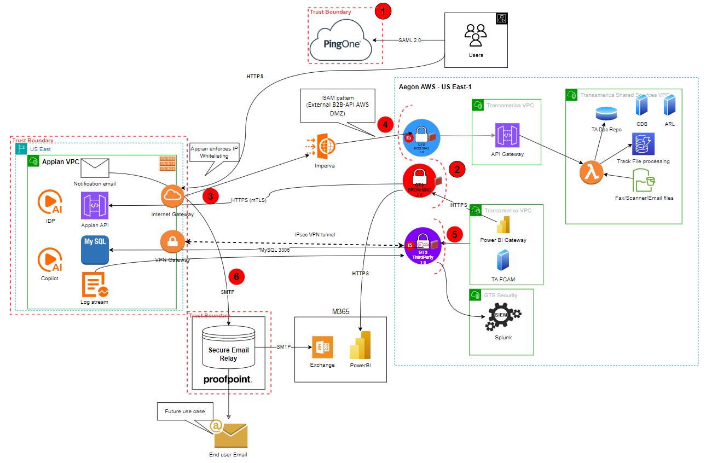

Security Boundaries Table
Security Boundary Reference |  | Existing Pattern | Description
1 | User and Admin access | SSO | TA users access to Appian platform using standard PingOne SAML 2.0 pattern
2 | Egress to internet | GTS AWS Browsing Pattern | Egress to internet control by Palo Alto firewalls with least privileged firewall rules
3 | Appian Internet gateway | SaaS | IP whitelisting restricts access to only Aegon egress IPs and protected by SSO for user access and mTLS connections for API access
4 | TA API gateway | GTS AWS Hosting pattern | Ingress controlled by F5, Palo Alto firewalls and ISAM
5 | IPSec VPN | B2B VPN service | Private connection between Appian and Aegon data center using aes-256-cbc encryption algorithm and sha2-256 authentication. Least privileged firewall rules for required traffic
6 | SMTP to Proofpoint SER | Proofpoint SER | Secure email relay solution authenticated using SMTP protocol

Security Review Outcomes
Text

Threat Model Assessment - full document link
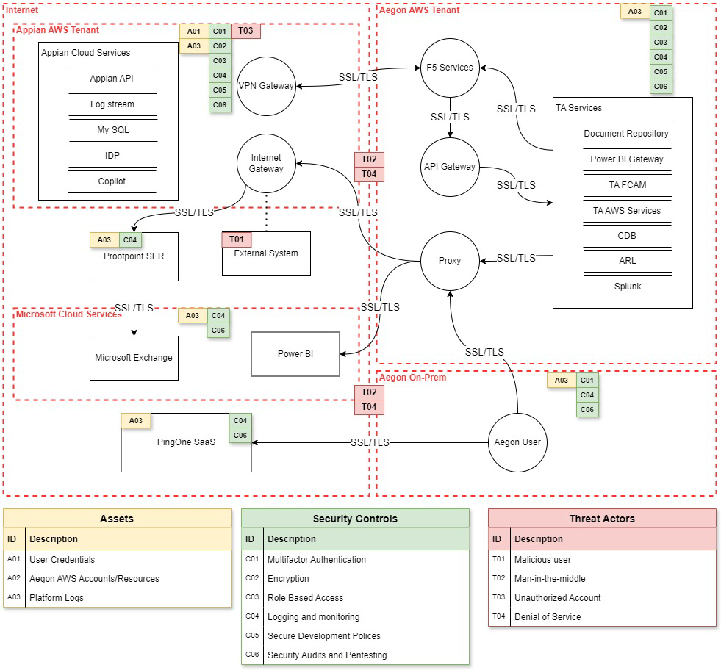

Data Solution

Data Classification
Data Confidentiality Classification |  | Data Legal and Regulatory Classification
☒ | Strictly Confidential | ☒ | Financial Information
☒ | Confidential | ☒ | Personal Identifiable Information
☐ | Internal | ☒ | Protected Health Information
☐ | Public | ☐ | Payment Card Information
☐ | No Data Shared | ☐ | No Personal Data Shared

Privacy Impact Assessment (PIA)
Underway

Data Encryption
Default value used by Appian is AES 256

Data Retention
TBD based on business requirements

Data Residency
Appian runs in AWS US East

GenAI (Future v.3)
TA registered Appian IDP under TA024 and Appian AI Copilot in Gen AI inventory under entry TA030.
TA inventory Gen AI Inventory.

Aegon GenAI - Home (sharepoint.com)
Gen AI Policy

Service Model

Appian shared responsibility
With Appian there is a shared responsibility model between Appian, Transamerica and GTS.
Appian provides the Saas Solution which include infrastructure, physical security, network security and platform security. Also accountable to for service availability, data protection, and compliance.
Transamerica is accountable for configuring the platform, workflows, data governance (permissions, roles, use cases), as well as monitoring workflows.
GTS is responsible for network connectivity, Proofpoint SER service, and Power BI services.

RACI Chart

Key Activity, Milestone, or Decision | Business Units | Global Enterprise Architecture | Global Infrastructure Platform Engineering | Global Information Security Services | BISO
Application Security Governance
Own Application Security capability | C/I | C/I | C/I | R/A | C/I
Define and maintain (adoption) strategy | C/I | R/A | C/I | R/A | C/I
Communicate (adoption) strategy | C/I | C/I | C/I | R/A | C/I
Define and maintain roles & responsibilities | C/I | C/I | C/I | R/A | C/I
Align Security strategy with Business Objectives | C/I | C/I | C/I | R/A | C/I
Define and describe policies & standards | C/I | C/I | C/I | R/A | C/I
Define application security objectives | C/I | C/I | C/I | R/A | C/I
Architecture
Create Tooling Architecture | C/I | R/A | C/I | C/I | C/I
Arrange ARB approval | C/I | R/A | C/I | R/A | C/I
Tooling implementation & Maintenance

Define tooling requirements | C/I | C/I | C/I | R/A | C/I
Select tools | C/I | C/I | C/I | R/A | C/I
Arrange required budget for tooling licences | C/I | C/I | R/A | C/I | C/I
Arrange required budget for resources maintaining tools |  |  | R/A | C/I | C/I
Implement and maintain tools | C/I | C/I | R/A | C/I | C/I
Implement required integrations | C/I | C/I | R/A | C/I | R
Conduct license management | C/I | C/I | R/A | C/I | C/I
Implement required reporting | C/I | C/I | R/A | C/I | C/I
Automate manual and repeatable activities | C/I | C/I | R/A | C/I | C/I
Deliver standard pipeline scanning building blocks | C/I | C/I | R/A | C/I | C/I
Organise DevSecOps community sessions | C/I | C/I | R/A | C/I | C/I
Training, Education & Roll Out
Identify and deliver training capabilities | C/I | C/I | C/I | R/A | C/I
Conduct developer training | R/A |  | C/I | C/I | C/I
Conduct security officer training | C/I |  |  | C/I | R/A
Conduct security awareness sessions | C/I | C/I | C/I | R/A | C/I
Conduct DevSecOps assessment per BU | C/I | C/I | C/I | C/I | R/A
Deliver Improvement plan as outcome of DevSecOps assessments | C/I |  |  | C/I | R/A
Ensure sufficient time is available for vulnerability remediation | R/A |  |  |  | C/I
Check scanning reporting results | R |  |  |  | R/A
Escalate to management if right follow up on scanning results and reporting is lacking | C/I |  |  | C/I | R/A
Scanning and mitigation
Conduct scanning | R/A |  | C/I | C/I
Prevent and resolve software security issues | R/A |  |  |  | C
Request false positive or exception check if required | R/A |  |  |  | C/I
Judge outcome false positive or exception requests | C/I |  |  |  | R/A
Administer outcome in ServiceNow VR | C/I |  |  |  | R/A

Implementation Approach

Proposed level of coordination
GTS services will be request via ASK requests
- VPN Connection
- Firewall requests
- Messaging and Collaboration for Email integration
- Enablement of Power BI gateway to allow connection to GTS managed m365 tenant

Dependencies
None

Licensing
Transamerica is owning license management

Artifacts
Review Process and Acknowledgements
In Scope | Owner | Non-Architecture Review / Assessment Process | Point of Contact | Link to Acknowledgement or Evidence
☐ | Internal Compliance & Controls | Technology Risk Assessment (only for Core and Common designs) | n/a- distinct solution for TA | n/a – no new patterns
☒ | GTS – Information Security | Information Security Review (process in development and will replace security review section) | Nick Russel, Chad Hunter, or Jeff Bain | Approved on ARB 06/05/2025
☒ | GTS – Information Security | Threat Model | Paul Nickelson, Jeff Bain | Link
☒ | Data Privacy | Data Privacy Impact Assessment (OneTrust) | Adam Kaminski | DPIA Number - 12043
☒ | GTS - Architecture | Approved Architectural Artifacts Added to Architecture Repository | Jarred Recker | Link
☒ | TA Gen AI committee | Gen AI review and Inventory | Amy Sandstrom | TA024 – Appian IDP  TA030 – Appian AI Copilot

Waivers and/or Exceptions
GTS Architecture Review Board (ARB) provides a governance framework for Architecture Risk. The GTS ARB will review and approve/reject solution Architecture Exceptions.
See this link for documentation related to Exceptions to Standards.
<start of excerpt from the above document>
The GTS ARB holds the responsibility for ensuring that risk acceptances and/or risk remediations for exceptions to standards are approved and documented within architecture templates before granting GTS Final ARB approval. The assigned architect is responsible for memorializing the GTS Risk Acceptances and GTS Risk Remediations within the Waivers and/or Exceptions section of the architecture template that is being presented for GTS ARB approval.
Risk Acceptance and Risk Remediation compliance is a function of the GTS internal risk management process. Exceptions to standards are logged as GTS Risk Acceptances or GTS Risk Remediations.
- GTS Risk Acceptances are logged for exceptions to standards that are not planned to be remediated. GTS Risk Acceptances will be reviewed annually though the GTS internal risk process to ensure that the risk acceptance without remediation remains acceptable.
- GTS Risk Remediations are logged for exceptions to standards that are intended to be remediated. Risk remediations require a remediation plan with a remediation date that identifies the commitment to remediate the risk. GTS Risk Remediations are required to be remediated within 12 months.
<end of excerpt from the above document>

Risk Acceptances
# | Acceptance Title | Exception Description | Link to Risk Exception Acceptance
1
2
3

Risk Remediations
# | Remediation Title | Exception Description | Link to Risk Exception Remediation
1
2
3

Security Exceptions
# | Exception Title | Exception Description | Link to Security Exception
1
2
3

Estimated Costs
Costs are managed by TA as this is a distinct solution for TA

Exit Strategy
Research and vet alternative solutions that meet or exceed the business and technical requirements. Develop a detailed exit strategy defined by:
- Method Selection
- Exit Scope and Timeline
- Roles and Responsibilities
- Contract Review
Appendix A: Architecture Review Board Scorecard
<link to scorecard>

Appendix B: Related Documents
Links and other pertinent references

Appendix C: Glossary of Terms and Acronyms

